Lab 13-15: Final Project –

Sage-Grouse, Grazing and Fire

Alex Traynor

Nelson Stauffer

Kyndal Olin

April 27, 2018

## Introduction

The Greater sage-grouse (*Centrocercus urophasianus*) is a large, ground-dwelling bird dependent on sagebrush ecosystems for nesting, foraging, and mating (Connelly et al. 2004). *C. urophasianus* lives and reproduces in sagebrush communities, thus making the preservation of sagebrush ecosystems a key factor in protecting *C. urophasianus*. Not only does *C. urophasianus* require a sagebrush community, but they specifically require a mosaic of sagebrush species with a diverse array of perennial grasses and forbs to complete their life-cycle (Bureau of Land Management 2008).

Over the years *C. urophasianus* has become an iconic bird in sagebrush habitat restoration. Although it is no longer listed under the Endangered Species Act, there is still effort by different entities to help ensure its habitat is protected (Endangered and Threatened Wildlife 2010). One organization activity working to protect sagebrush habitat in Nevada is the Nevada Department of Wildlife (NDOW). One project currently underway is the mitigation of Single-leaf piñon (*Pinus monophylla)* and Utah juniper (*Juniperus osteosperma)* encroachment into sagebrush ecosystems. *C. urophasianus* require adequate area in sagebrush communities to perform their courtship dance and invasive tree populations in sagebrush communities have been shown to decrease the availability of lek areas. As few as 4% conifer cover has been shown to have negative impacts on their leks (Baruch-Mordo et al. 2013).

In an act to protect sagebrush habitat from single-leaf piñon and utah juniper encroachment NDOW initiated a project the implementing tree removal at conifer encroachment sites. The project removed trees at certain plots, while leaving control plots to see if tree removal would improve sagebrush habitat for the *C. urophasianus*. We anticipate the project to indicate that treatment locations provide a more suitable habitat for the birds than control plots.

## Methods

NDOW is performing juniper and piñon removal across Nevada, but for our purposes we focused on one project site, Patterson Pass. The site is in Eastern Nevada and is composed of 28 plots that were randomly generated within the site using parameters chosen by the project supervisor. Each plot was established and monitored before tree removal treatment in 2013 and revisited post-treatment in 2017. Chaining treatments were completed in January 2015 and lop and scatter treatments were completed in three parts—in September 2013, August 2014, and August 2015—meaning that the plots had recovery periods of two to four years.

The area was treated through two tree removal techniques, lop and scatter or tree chaining. Additionally, some plots were left untreated to use as a controls for comparison. Each plot was surveyed before and after treatment following a set of protocols and methods adapted from those used by BLM Assessment, Inventory, and Monitoring projects (Herrick 2017). For our analysis, we used only cover data collected from the line-point intercept (LPI) method. LPI data were collected using the same method as AIM along three 50-meter transects in a radial spoke design as on standard AIM plots (Herrick 2017).

At plot establishment GPS coordinates were taken, along with plot and site attributes, providing point pattern data with associated plot and vegetation cover attributes. We mapped the points and treatment polygons to give a visual of the treated and non-treated sites (Figure 1).

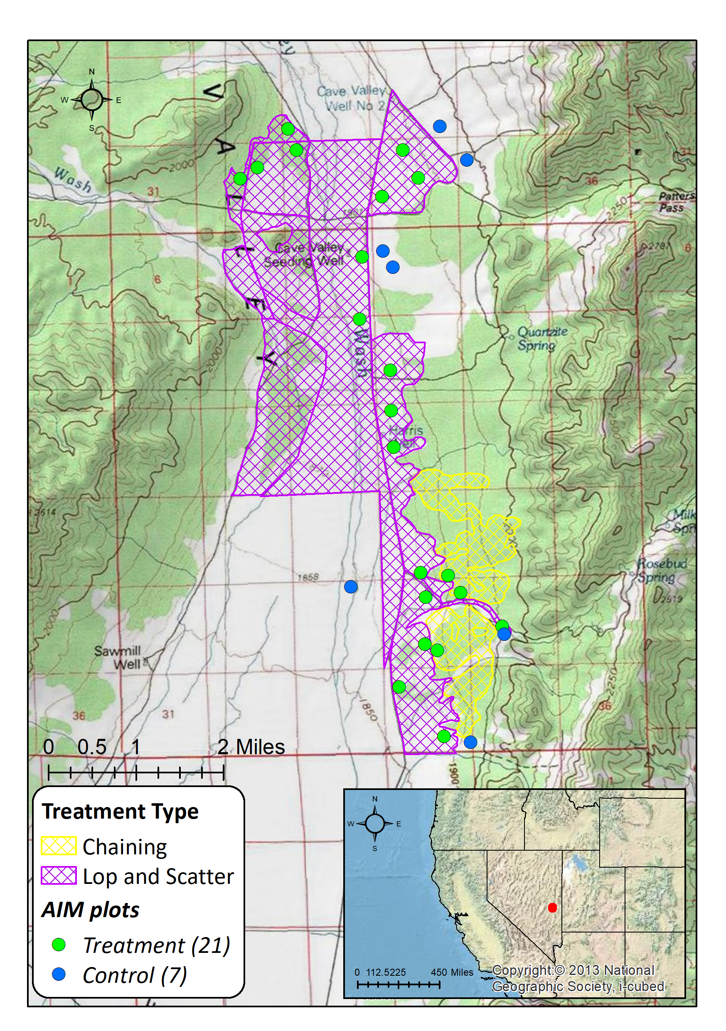

*Figure 1: Map of Patterson Pass treatment areas in central eastern Nevada. AIM plots were randomly placed within each treatment area with 4 plots in the Chaining treatment and 17 in the larger lop and scatter treatment. 7 plots outside the treatment boundaries were used as controls.*

|  |  |  |  |
| --- | --- | --- | --- |
| **Indicator** | **Precipitation Regime** | **Season of Sage-Grouse Use** | **Acceptable Range** |
| Non-invasive Tree Cover | Arid | Any | 0% <= X <= 1.5% |
| Invasive Annual Grass Cover | Arid | Any | 0% <= X <= 5% |
| Sagebrush Cover | Any | Spring | 20% <= X <= 100% |
| Non-invasive Perennial Grass Cover | Any | Spring | 10% <= X <= 100% |
| Non-invasive Shrub Cover | Any | Spring | 30% <= X <= 100% |
| Non-invasive Perennial Forb/Grass Cover | Any | Summer | 15% < X <= 100% |
| Non-invasive Perennial Forb Cover | Arid | Summer | 5% <= X <= 100% |
| Non-invasive Perennial Forb Cover | Mesic | Summer | 15% <= X <= 100% |
| Sagebrush Cover | Arid | Summer | 10% <= X <= 25% |

*Table 1: Benchmarks for the Nevada Sage-grouse Management Plan.*

To assess vegetation response at the plots we compared the percent cover of vegetation classes to the standards outlined in the Nevada Sage-grouse Management Plan. These were described in a machine-readable format as the ranges of cover required by the birds—dependent on the season of use and precipitation regime—as determined by Nevada to be adequate for their management objectives (Table 1). Comparing vegetation cover requirements of *C. urophasianus* to the plots actual cover values pre-treatment, post-treatment, and at control sites can show if treatments improve habitat quality for the birds. The scale of analysis was by treatment sites, but by comparing individual plots’ values within a site to neighboring plots, we can evaluate how vegetation has responded to treatments.

## Results

The LPI data were summarized into foliar cover indicators (*e.g.* “Perennial Non-woody Cover”) for each plot using the built in reporting functionality of the database they had been collected in. Those indicator values were tied to relevant contextual traits including precipitation regime and date of sampling so that the appropriate indicator range classes from the benchmark tool could be applied.

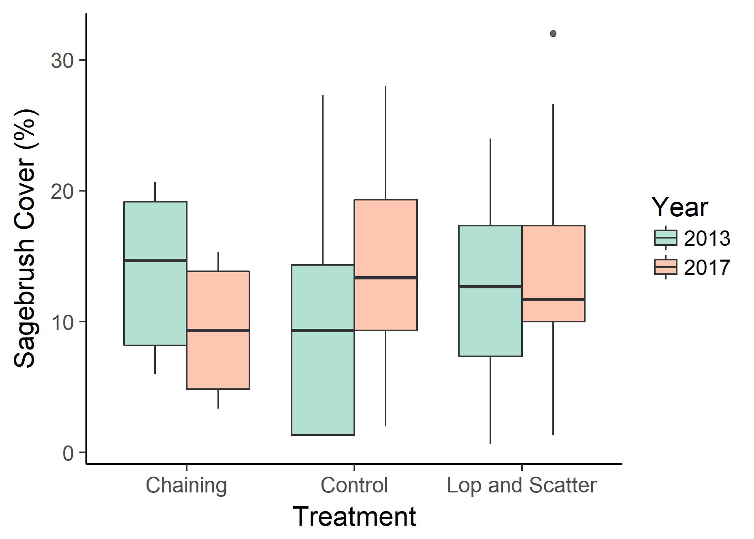

*Figure 2: The distribution of sagebrush cover values by treatment and year. The control sites evidently included some low-sagebrush locations in 2013, which contributes to a seeming increase in sagebrush cover. The chaining site saw a decrease, which is to be expected over this timescale*

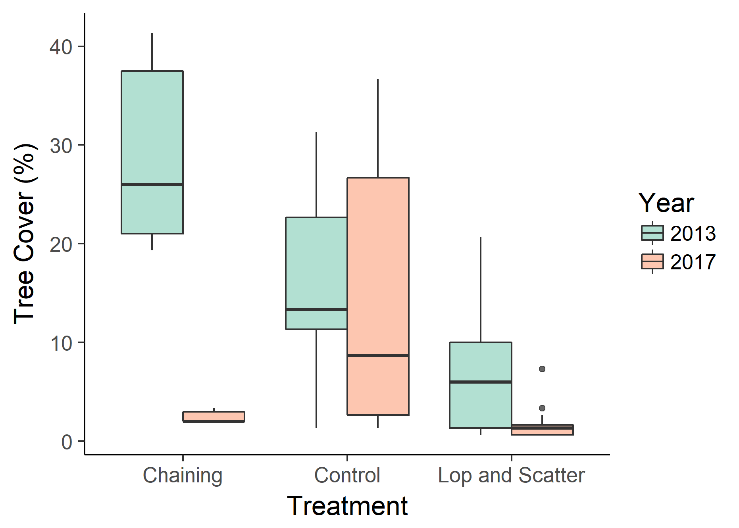

*Figure 3: The distribution of tree cover values by treatment and year. Both treatment methods resulted in dramatic reductions. Sites selected for chaining had significantly higher tree cover than the lop and scatter sites, likely due to management decisions related to predicted success and cost.*

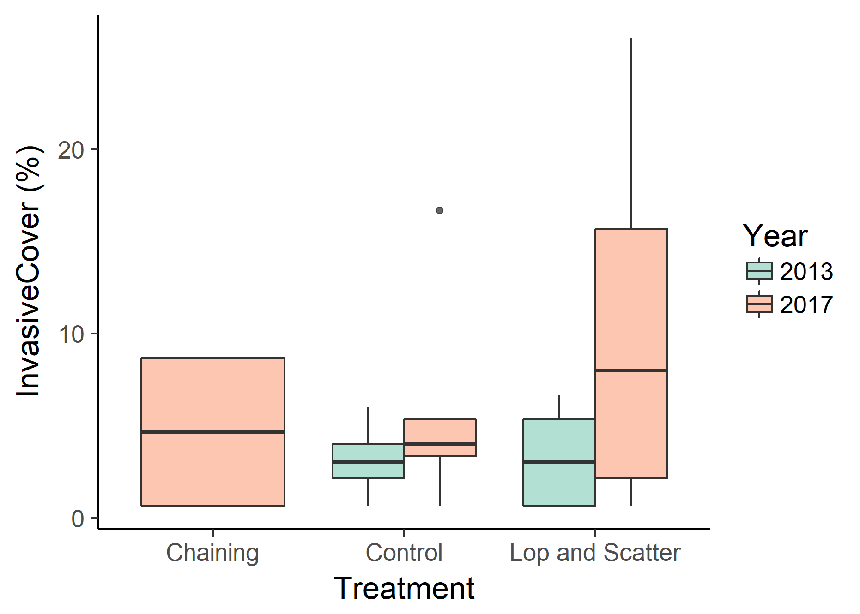

*Figure 4: The distribution of invasive plant cover values by treatment and year. There were no invasives recorded on chaining plots in 2013 and both treatments so large increases in invasive cover, in keeping with post-disturbance expectations.*

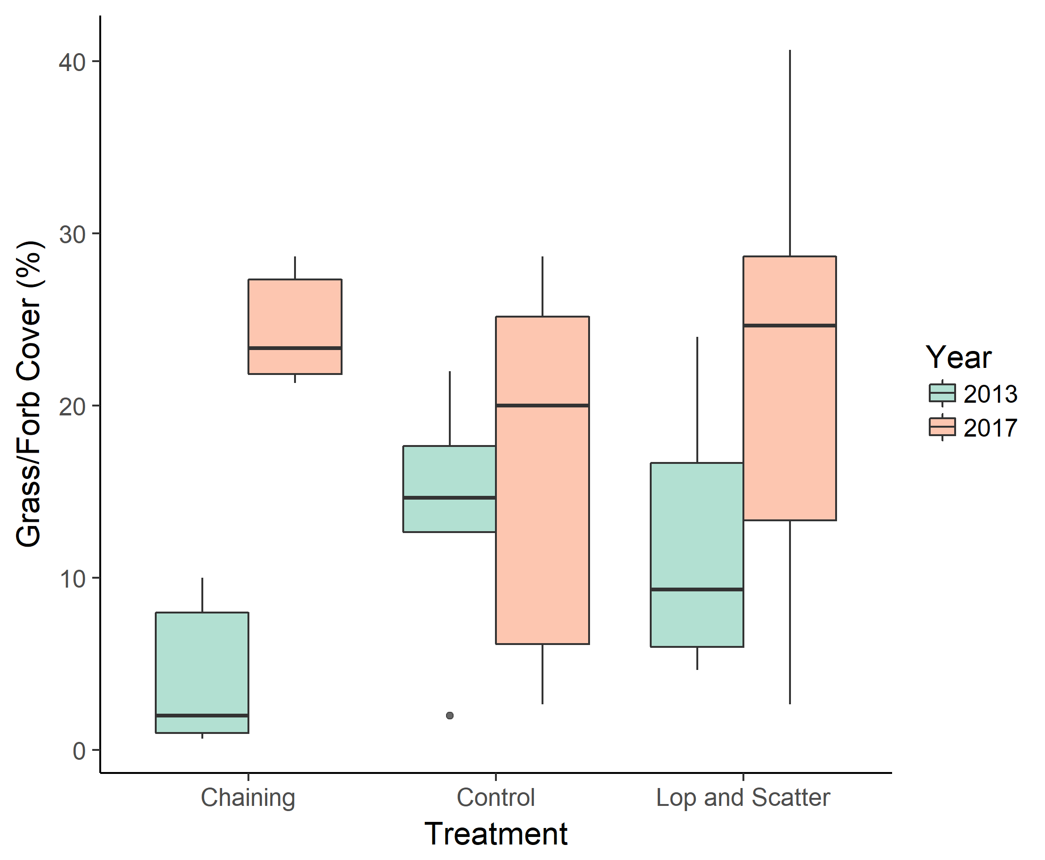

*Figure 5: The distribution of perennial grass and forb cover values by treatment and year. Although all three groups had increases in herbaceous cover, it was much more pronounced in the two treatments. The low herbaceous cover in 2013 pre-chaining may be related to the high tree cover on those plots.*

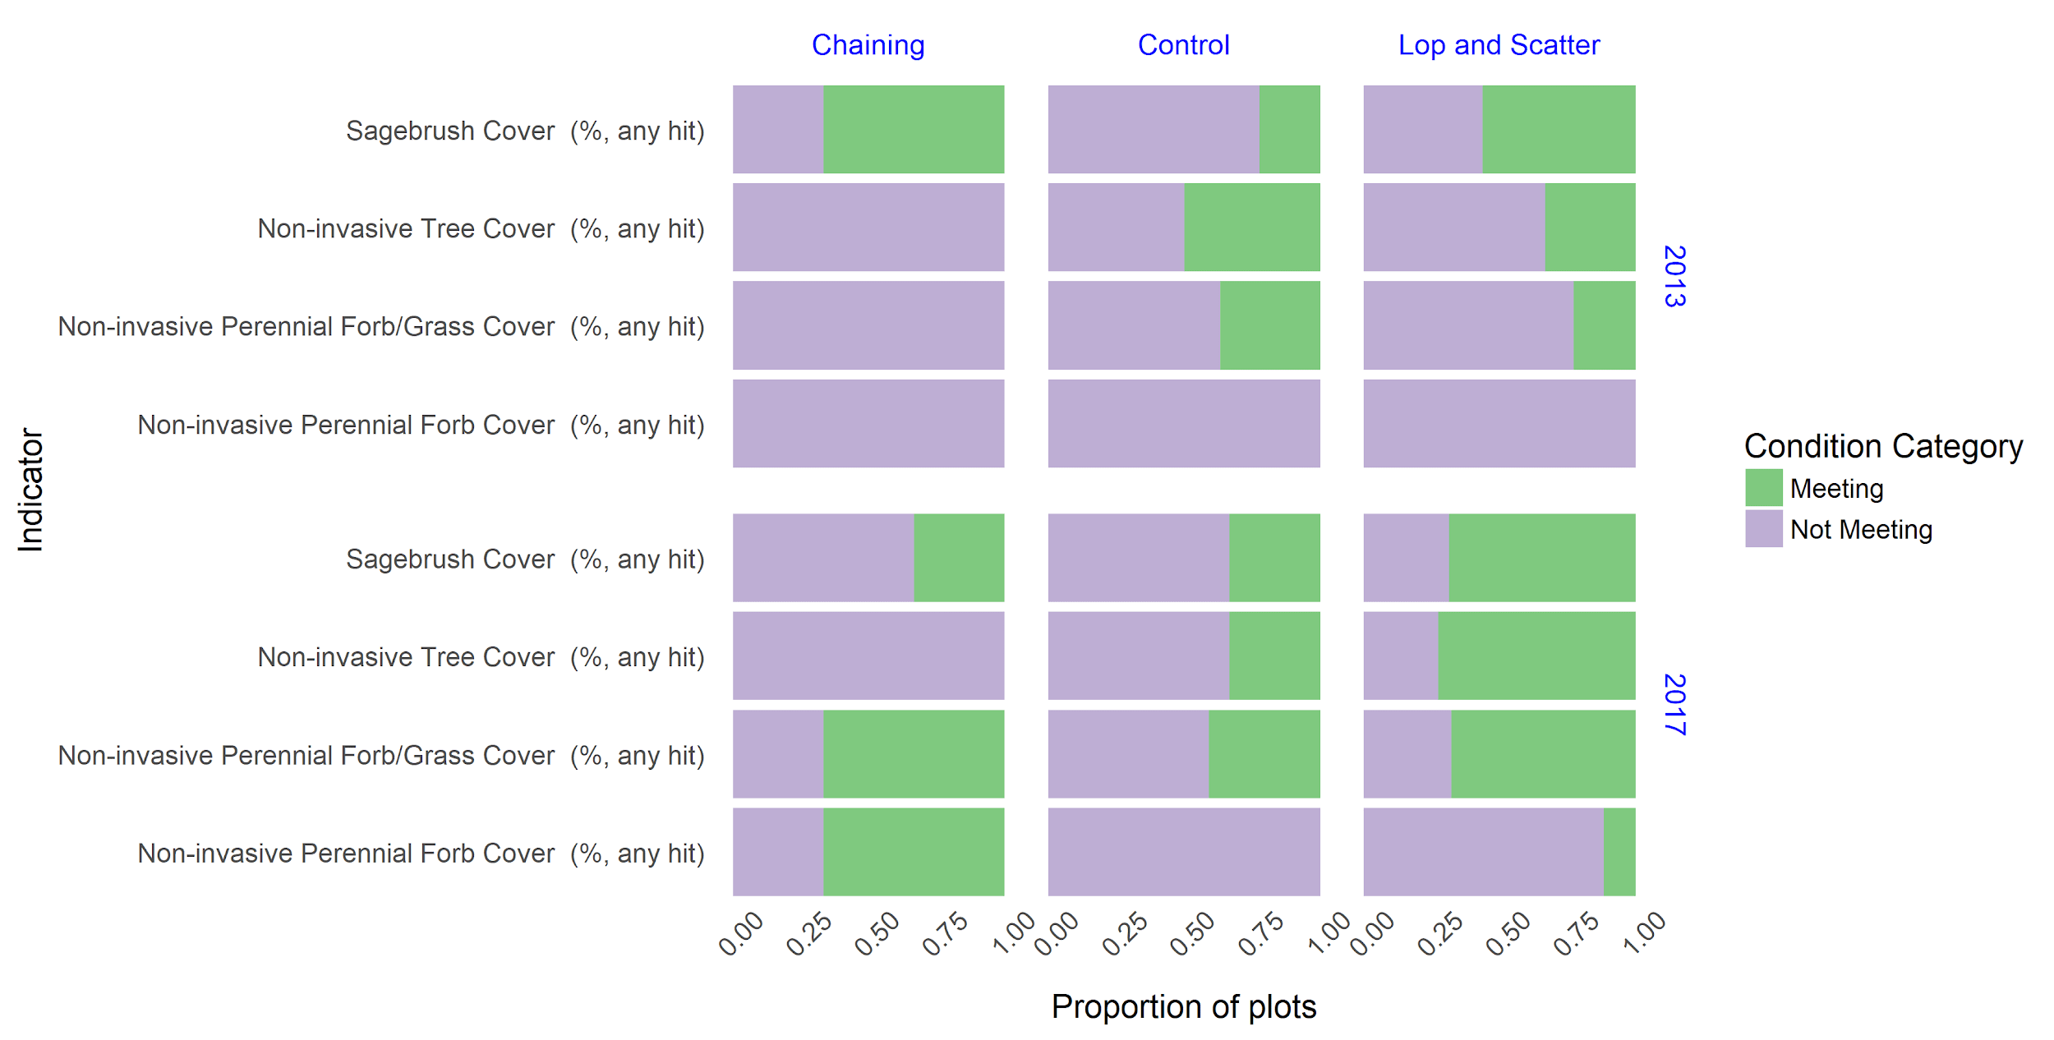

*Figure 6: The proportions of plots classified as meeting/not meeting management objective benchmarks by indicator, year, and treatment. There were no major changes between years for control points, but both the chaining and lop and scatter plots were much more likely to be meeting objectives after treatment.*

## Conclusions

Plots in both the chaining and lop and scatter treatments saw major shifts in vegetation composition, which pushed many indicators into meeting the described benchmarks (Figure 6). In the case of chaining, the amount of sagebrush cover was negatively affected, being less likely to meet the management objective benchmark post-treatment, which can be attributed to the non-selective nature of the treatment. This is in contrast to lop and scatter in which the crews can avoid damaging anything other than the targeted trees (Figure 2).

Although the control plots did not strongly resemble the treated plots in terms of raw indicator values (Figures 3, 5), they do show consistency in the classification of their values according to the benchmarks (Figure 6). This is one of the advantages to having management objectives that define classifications tied to ecological potential: where the indicator values may not be meaningfully comparable, converting them to a common classification scheme means that even comparisons across ecosystem types (*e.g.* arid versus mesic systems) are possible and responsible.

Based on these results, it appears that the treatments were appropriate for the systems they targeted. However, there are not necessarily conclusions that can be drawn from these data to guide treatment selection for sites: although the treatments were successful, the experimental design for sampling and treatment selection method for each plot do not provide information on whether a site may have fared even better with the other treatment type.

## Literature Cited

Baruch-Mordo, S., J.S. Evans, J.P. Severson, D.E. Naugle, J.D. Maestas, J.M. Kiesecker, M.J. Falkowski, C.A. Hagan, and K.P. Reese. 2013. Saving sage-grouse from the trees: a proactive solution to reducing a key threat to a candidate species. Biological Conservation 167:233-241.

Bureau of Land Management. 2008. Lincoln County sage grouse habitat restoration project. Environmental Assessment (EA) NV 040-08-05.

Connelly, J.W., S.T. Knick, M.A. Schroeder, and S.J. Stiver. 2004. Conservation assessment of greater sage-grouse and sagebrush habitats. Unpublished Report, Western Association of Fish and Wildlife Agencies. Cheyenne, WY. 610pp.

Endangered and Threatened Wildlife and Plants; 12-Month Findings for Petitions to List the Greater Sage-Grouse (*Centrocercus urophasianus*) as Threatened or Endangered. 50 C.F.R. § 17 (2010).

Herrick, Jeffery E., Justin W. Van Zee, Sarah. E. McCord, Ericha M. Courtright, Jason W. Karl, Laura M. Burkett. 2017. Monitoring Manual for Grassland, Shrubland, and Savanna Ecosystems, Second Edition. USDA - ARS Jornada Experimental Range. Las Cruces, New Mexico